Advisors’ Guide for Grade Forgiveness

# The Policy

Advisors can review the current Grade Forgiveness Policy in the Undergraduate Catalog – Academic Regulations – Institutional Grading Policies – Grade Forgiveness Policy: <http://catalog.uta.edu/academicregulations/grades/#undergraduatetext>.

Language related to “exclusions” and “replacements” has been modified to “omission” and “substitution,” respectively, within the Grade Forgiveness Policy to avoid confusion with former Grade Replacement and Exclusions policies.

# General Process

1. **First-time-in-college freshman students** who entered UT Arlington **Fall 2013 or after** will be able to utilize the Grade Forgiveness Policy. The student must work with an academic advisor in their major department to complete the grade forgiveness request process.
2. The academic advisor will complete a separate Grade Forgiveness Request Form for each of the two grade forgiveness options available via a workflow in SharePoint.
3. **The Grade Forgiveness Request Forms will be available for academic advisors to complete for a student from Census Date of the term or session through the Last Drop Date.** Once the academic advisor has submitted the form, an email message will be sent to the Final Department Approver prompting that approver to review the request and approve or deny in accordance with University and department policies.
4. Once the Final Department Approver has approved or denied the request, the request will be sent to the Office of Admissions, Records and Registration (ARR) for final processing. ARR will not serve as a gatekeeper for the policy, so the departments must fully vet the student in accordance with University and department policies to ensure consistent administration across campus.
5. The student will receive an email notification once the final approval or denial has been processed by ORR.

Questions related to the processing of a grade forgiveness request can be sent to ARR - [forgiveness@uta.edu](mailto:forgiveness@uta.edu) - for feedback.

**Identifying First-Time-in-College Students**

Students are identified in MyMav as first-time-in-college (FTIC) by admission type and recruiting category.  Examples:

* **ADMIT TYPE** = 1 (New Freshman)
  + Navigation:  [Student Admissions](https://sis-portal-prod.uta.edu/psp/AEPPRD/EMPLOYEE/EMPL/s/WEBLIB_PT_NAV.ISCRIPT1.FieldFormula.IScript_PT_NAV_INFRAME?pt_fname=HCAD_STUDENT_ADMISSIONS&c=Cf8IEjA%2fEMBMNNtjmMBK1Y%2bE1ioW4iPOP0fMUCl6Ap4%3d&FolderPath=PORTAL_ROOT_OBJECT.HCAD_STUDENT_ADMISSIONS&IsFolder=true) > [Application Maintenance](https://sis-portal-prod.uta.edu/psp/AEPPRD/EMPLOYEE/EMPL/s/WEBLIB_PT_NAV.ISCRIPT1.FieldFormula.IScript_PT_NAV_INFRAME?pt_fname=HCAD_APPLICATION_MAINTENANCE&c=Cf8IEjA%2fEMBMNNtjmMBK1Y%2bE1ioW4iPOP0fMUCl6Ap4%3d&FolderPath=PORTAL_ROOT_OBJECT.HCAD_STUDENT_ADMISSIONS.HCAD_APPLICATION_MAINTENANCE&IsFolder=true) > [Maintain Applications](https://sis-portal-prod.uta.edu/psp/AEPPRD/EMPLOYEE/HRMS/c/PROCESS_APPLICATIONS.ADM_APPL_MAINTNCE.GBL?FolderPath=PORTAL_ROOT_OBJECT.HCAD_STUDENT_ADMISSIONS.HCAD_APPLICATION_MAINTENANCE.HC_ADM_APPL_MAINTNCE_GBL1&IsFolder=false&IgnoreParamTempl=FolderPath%2cIsFolder).  Tab =  Application Data.
  + Example: first screenshot below
* **RECRUITING CATEGORY**
  + **AUFR** = First-time freshman with no previous college work: Example - 1001262163
  + **AUFC** = First-time freshman with previous dual credit college work: Example - 1001163947
    - Navigation:  [Student Admissions](https://sis-portal-prod.uta.edu/psp/AEPPRD/EMPLOYEE/EMPL/s/WEBLIB_PT_NAV.ISCRIPT1.FieldFormula.IScript_PT_NAV_INFRAME?pt_fname=HCAD_STUDENT_ADMISSIONS&c=Cf8IEjA%2fEMBMNNtjmMBK1Y%2bE1ioW4iPOP0fMUCl6Ap4%3d&FolderPath=PORTAL_ROOT_OBJECT.HCAD_STUDENT_ADMISSIONS&IsFolder=true) > [Application Maintenance](https://sis-portal-prod.uta.edu/psp/AEPPRD/EMPLOYEE/EMPL/s/WEBLIB_PT_NAV.ISCRIPT1.FieldFormula.IScript_PT_NAV_INFRAME?pt_fname=HCAD_APPLICATION_MAINTENANCE&c=Cf8IEjA%2fEMBMNNtjmMBK1Y%2bE1ioW4iPOP0fMUCl6Ap4%3d&FolderPath=PORTAL_ROOT_OBJECT.HCAD_STUDENT_ADMISSIONS.HCAD_APPLICATION_MAINTENANCE&IsFolder=true) > [Maintain Applications](https://sis-portal-prod.uta.edu/psp/AEPPRD/EMPLOYEE/HRMS/c/PROCESS_APPLICATIONS.ADM_APPL_MAINTNCE.GBL?FolderPath=PORTAL_ROOT_OBJECT.HCAD_STUDENT_ADMISSIONS.HCAD_APPLICATION_MAINTENANCE.HC_ADM_APPL_MAINTNCE_GBL1&IsFolder=false&IgnoreParamTempl=FolderPath%2cIsFolder).  Tab =  Application School/Recruiting.
    - Example of student with multiple recruiting categories: 1000812734

**ADMIT TYPE:**

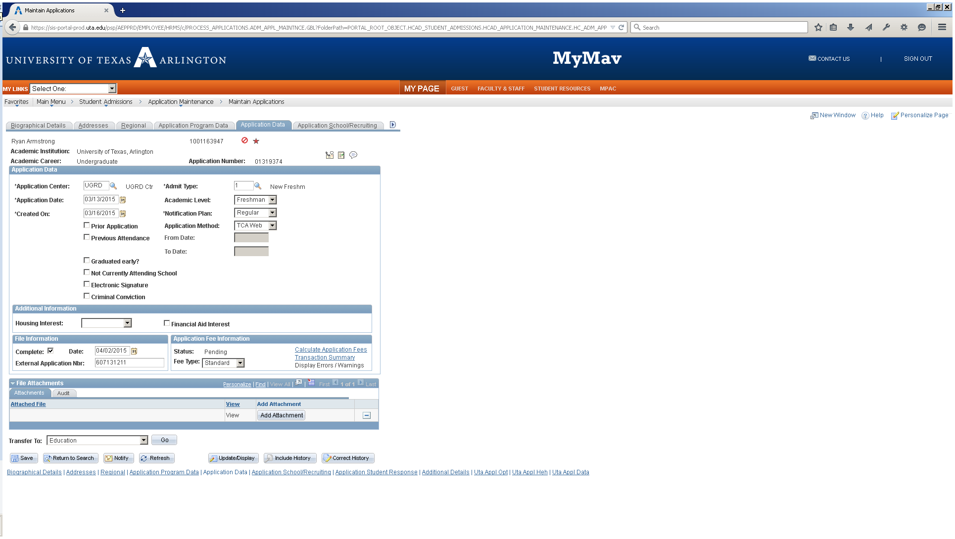

**RECRUITING CATEGORY:**

AUFR = First-time freshman with no previous college work

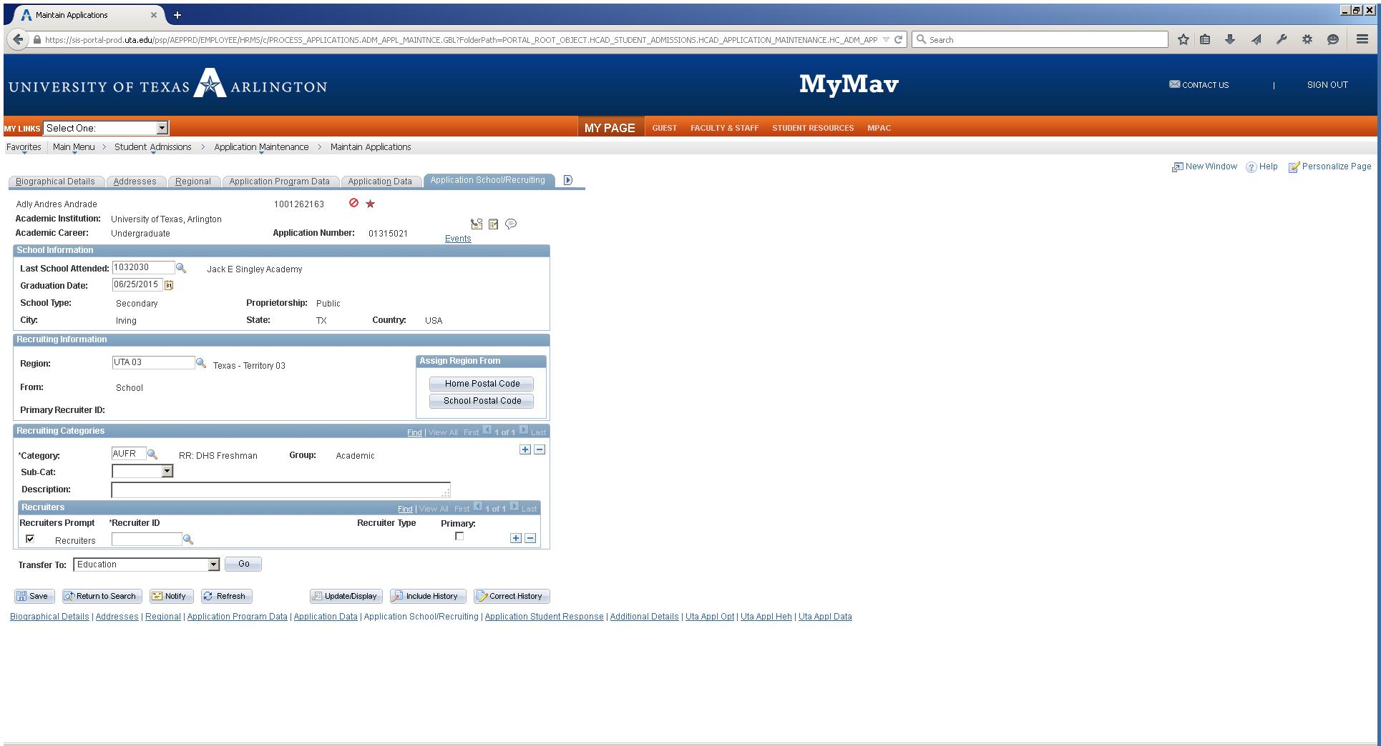

AUFC = First-time freshman with previous dual credit college work

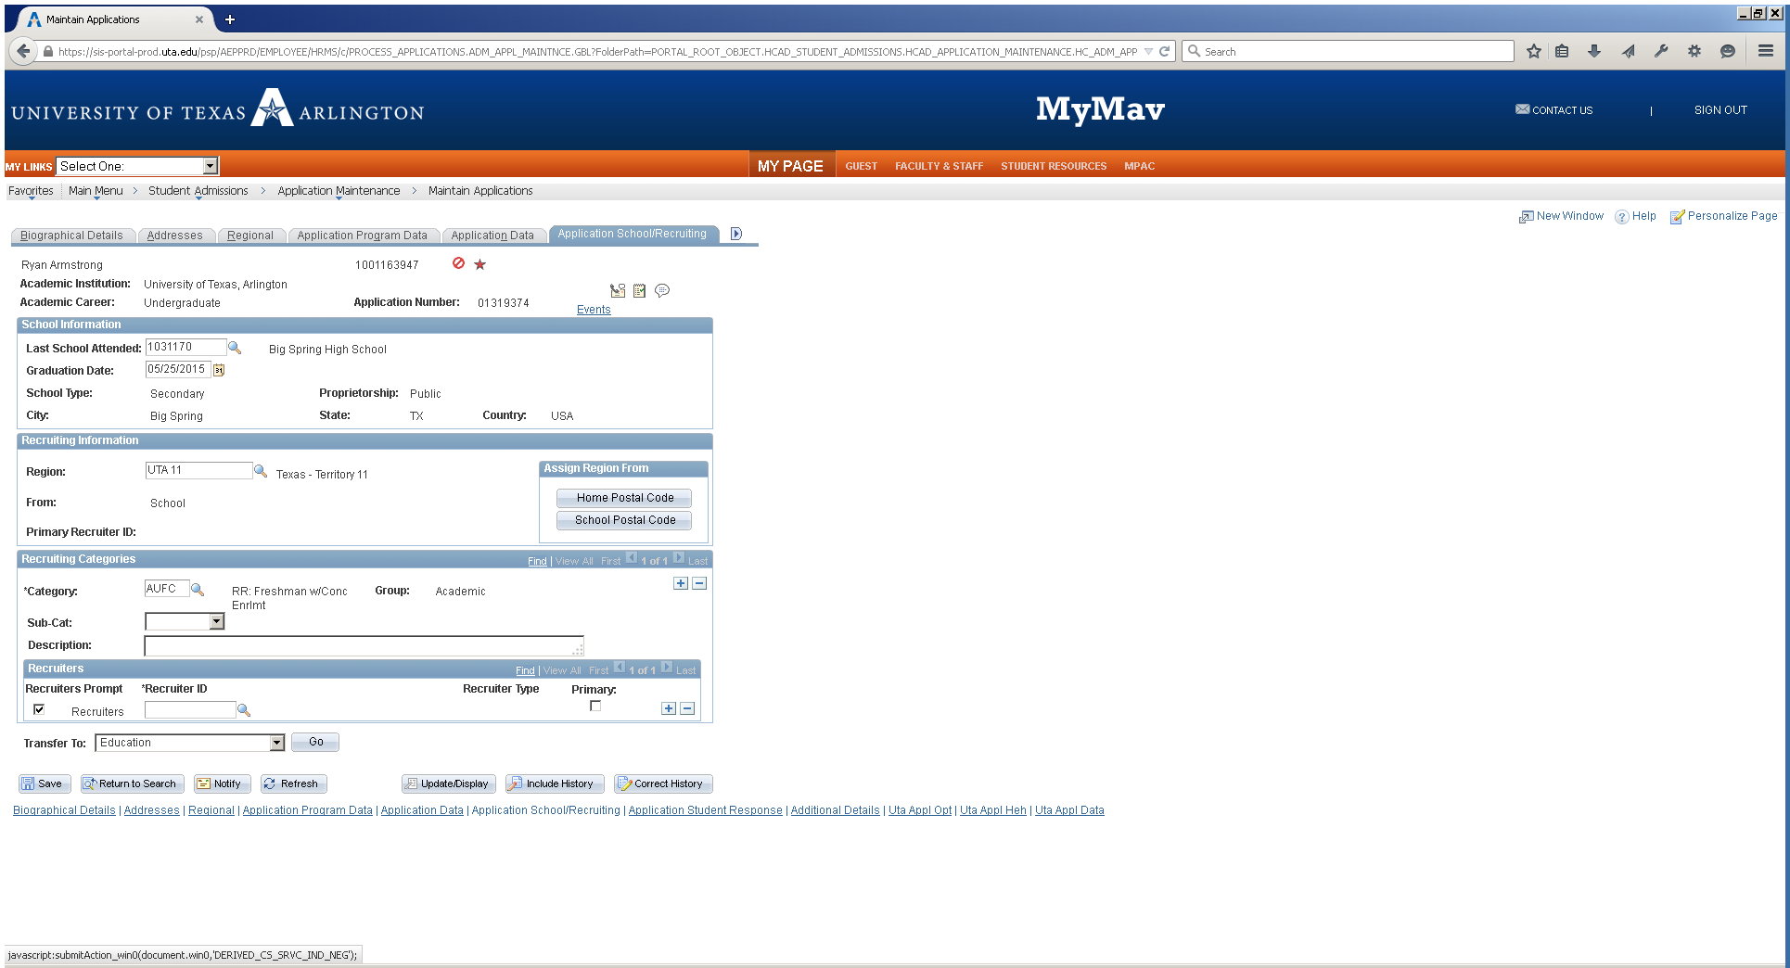

**RECRUITING CATEGORY – Example of student with multiple recruiting categories:**

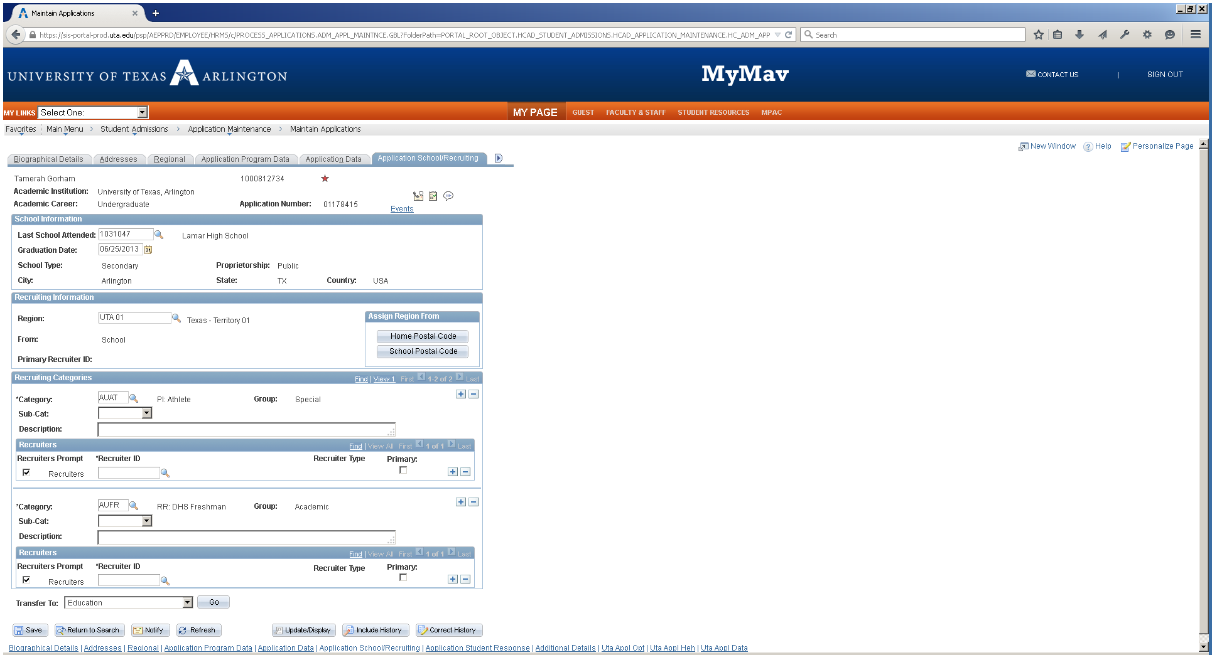

# Using SharePoint to Create Grade Forgiveness Requests

Advisors will access the form on a SharePoint location. SharePoint can be accessed from home computers with a functional VPN connection to campus. SharePoint functionality is maximized when used in Internet Explorer.

If issues cannot be resolved with the aids provided on the landing page (see below), questions related to the use and navigation within SharePoint can be sent to recordsandregistrationprocessing@uta.edu.

**SharePoint Location:**

[**https://acad.sp.uta.edu/sites/advisors**](https://acad.sp.uta.edu/sites/advisors)

*Figure 1: SharePoint Landing Page for Grade Forgiveness Requests*

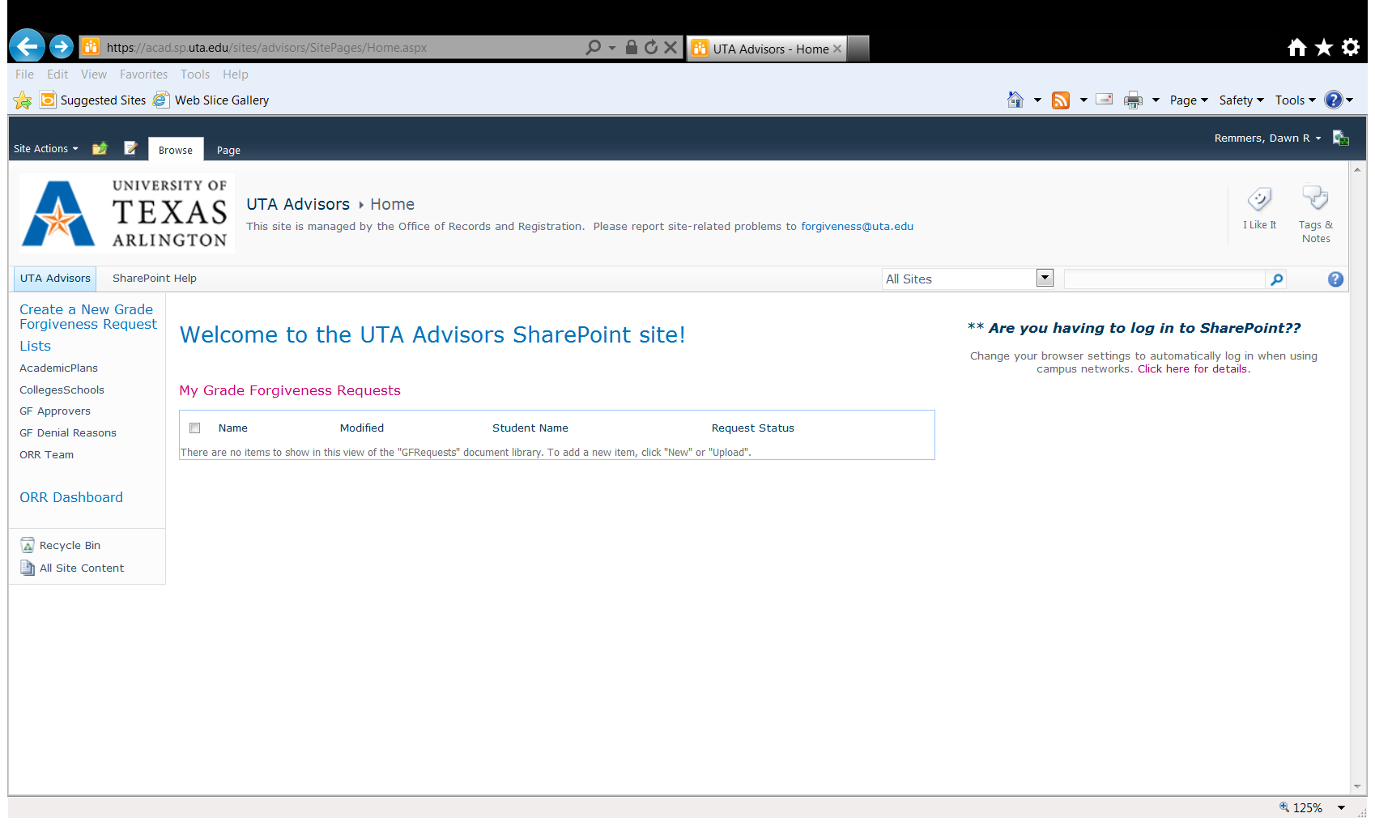

For those advisors who have not yet worked in SharePoint, the link circled in red (see Figure 1) may be helpful in: 1) setting up browsers to avoid continuous log-in prompts and 2) addressing frequently asked questions (via the link SharePoint_FAQ in the left menu). This job aid will also be available on this site as well as in the online Advisor Handbook.

# Security Access

For Advising Administrators, if a new academic advisor needs to have access to complete Grade Forgiveness Request Form, please request that access by emailing [recordsandregistrationprocessing@uta.edu](mailto:recordsandregistrationprocessing@uta.edu). The Advisor will be granted access to the Grade Forgiveness Request Form once he/she has completed the official MyMav Training offered by the University Advising Center.

Given the importance of the advising related to this issue, only staff who have consistent contact with students for advising should complete these requests even though they may have been granted access to the Undergraduate Advising Role to complete other duties that support academic advising. Likewise, if a department needs to request access for Final Department Approver, please request that access by emailing [recordsandregistrationprocessing@uta.edu](mailto:recordsandregistrationprocessing@uta.edu).

# How to Complete the Form

1. Click on “Create a New Grade Forgiveness Request” in the left menu.
2. Complete the Academic Advisor Information section (see Figure 2).

*Figure 2: Grade Forgiveness Request – Academic Advisor Information*

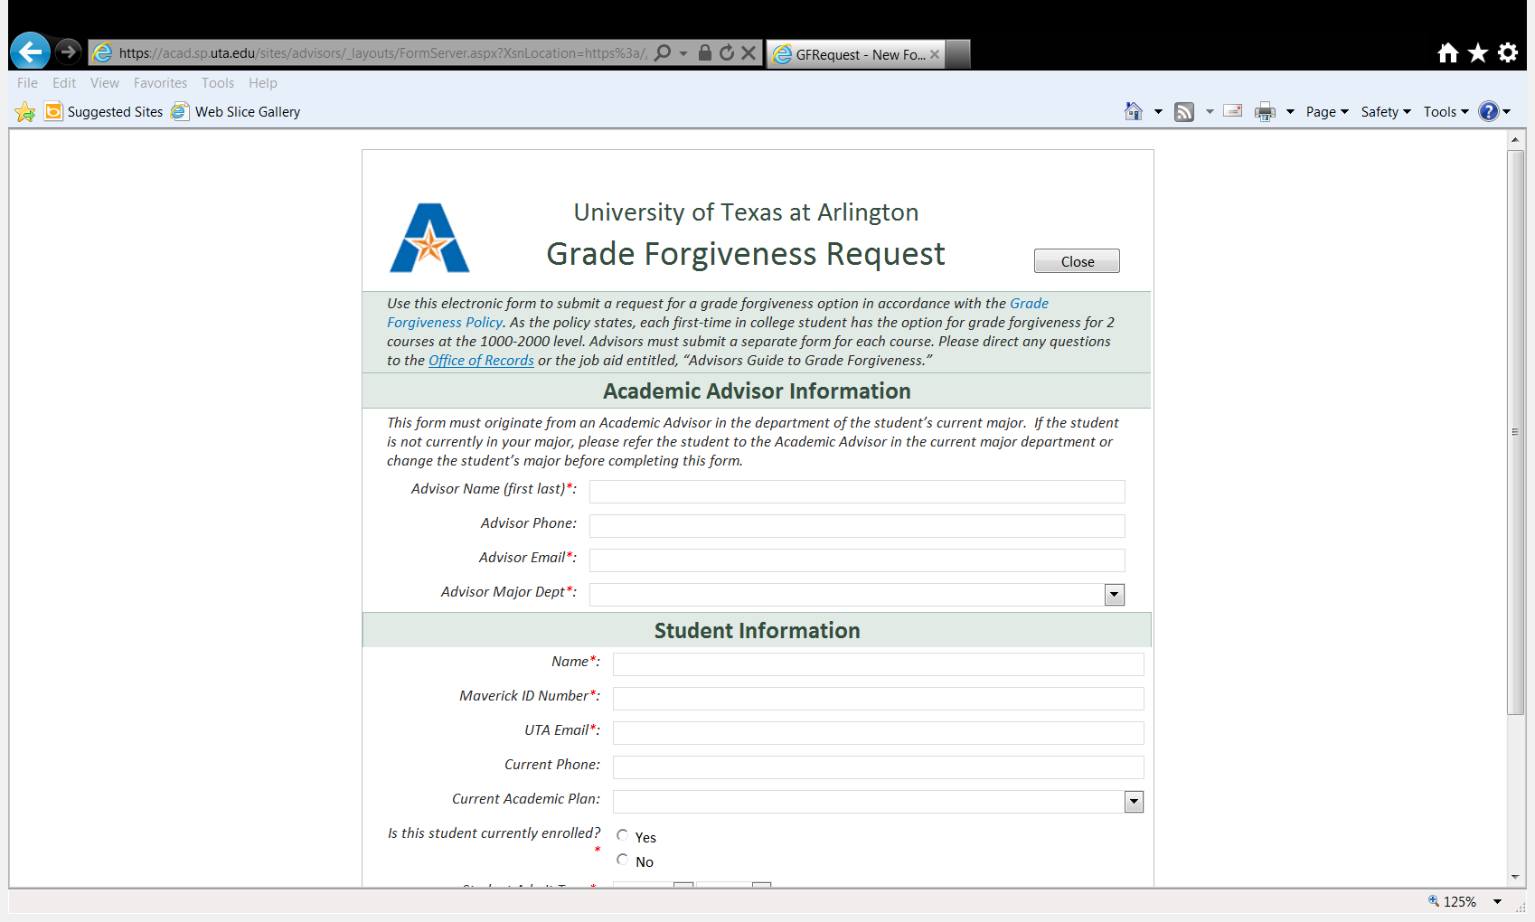

1. Items with a red asterisk must be completed for the form to submit.
2. **Do not** complete this form for a student that is not currently within your major.
3. **Do not** complete this form under another academic advisor’s name and authority.
4. **Do not complete this form for a student whose admit term (first term at UT Arlington) was prior to Fall 2013.**
5. Complete the Student Information section (See Figure 3).
   1. Items with a red asterisk must be completed for the form to submit.
   2. ***UTA Email***: Advisors must only enter the UTA Email address for the Student Information email. Students will receive email notifications related to the approval or denial of their request which will contain FERPA-protected information. Therefore, only the UTA email should be submitted on this form.
   3. ***Current Academic Plan***: Select the student’s current academic plan from the drop down menu provided. Advisors will only be able to select academic plans available to students from a particular college/school.
   4. ***Is the student currently enrolled?***: Select “Yes” if the student is: 1) enrolled in the current term or 2) if grades have posted at the end of the term and the student is enrolled for the following term. Select “No” option if the student is: 1) not currently enrolled at UTA and it is prior to official grades posting at the end of a term or 2) if grades are official at the end of a term and the student is not enrolled in the immediate following term. If advisors click “No,” the form will not submit for further processing (see Figure 6).
      1. Note: Once grades are deemed official by ARR, academic advisors will have access to complete the request forms, however, business practices dictate that ARR will not begin processing Grade Forgiveness Requests until Census of the next term to ensure the student is officially enrolled at that time as well.
      2. **Note:** **Students who may be able to improve their academic standing after completing a grade substitution once grades have posted may be a good candidates for Early Readmission consideration pending a post-Census grade change if the new grade can be verified and will make a difference in academic standing.**

*Figure 3: Grade Forgiveness Request – Student Information*

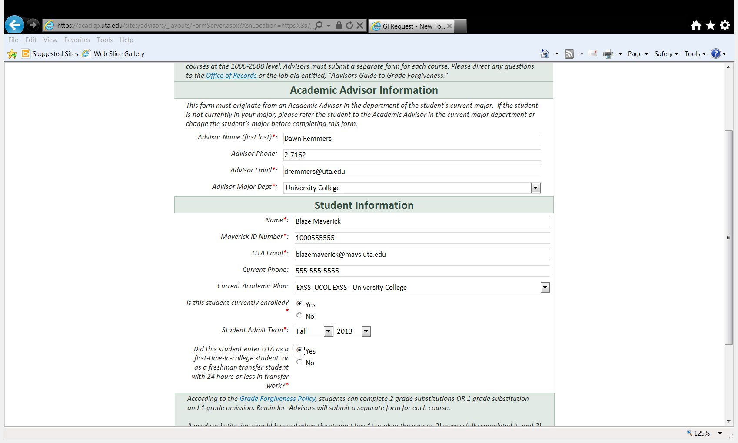

* 1. ***Student Admit Term***: Select the term and the year from the drop down menus. Advisors will not be able to submit a form for a student who entered prior to Fall 2013. Advisors can verify the Admit Term in MyMav > Campus Community > Student Services Center > Academics tab > Admit Term (See Figure 4). If the student was admitted prior to Fall 2013, advisors should review the Grade Exclusion or Replacement Policies for consideration.

*Figure 4: MyMav>Campus Community>Student Services Center>Academics tab>Admit Term*

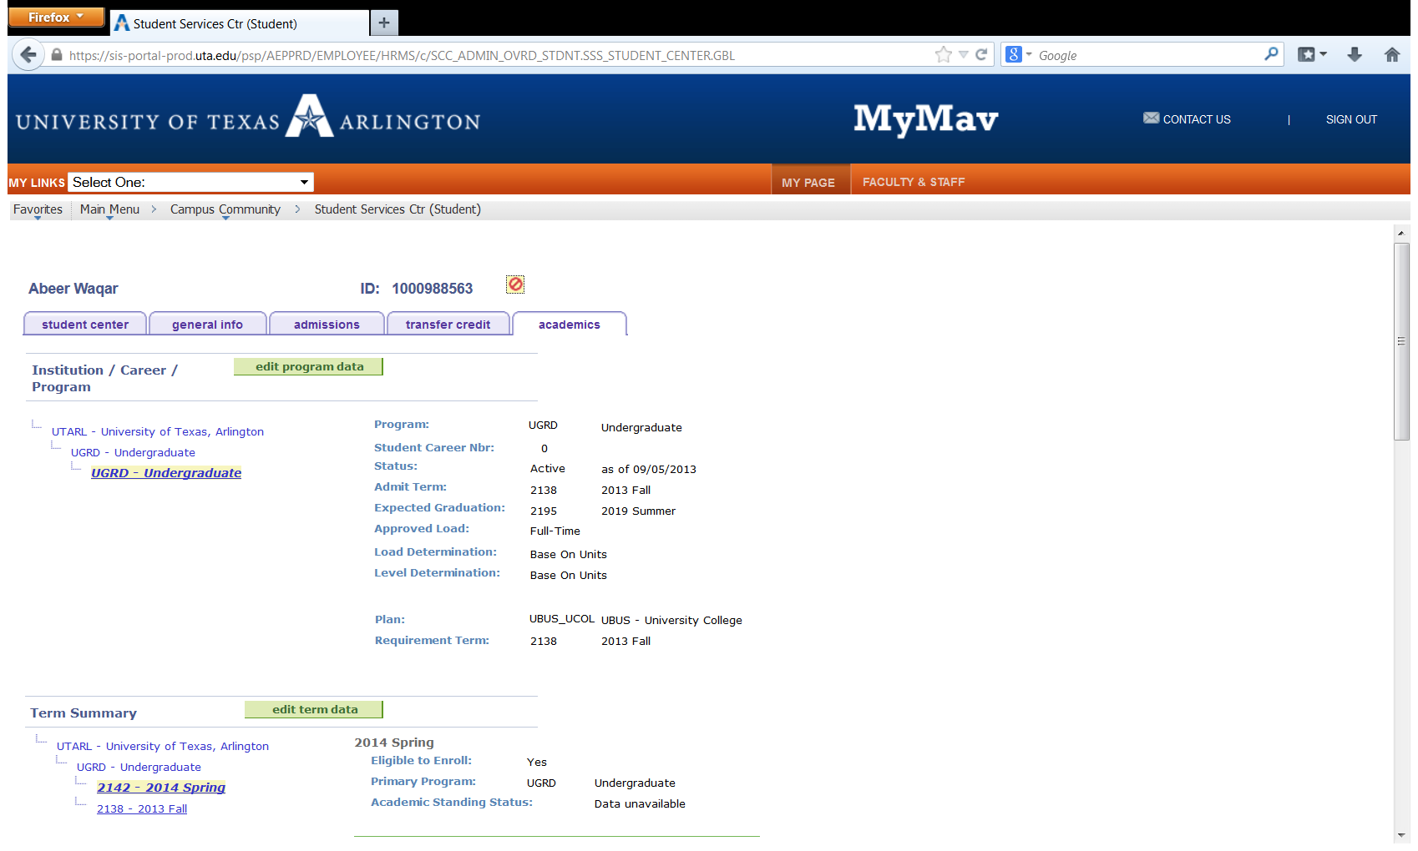

* 1. ***Did this student enter UTA as a first-time-in-college student…?***: Select “Yes” or “No.”
     1. To determine if a student was admitted as a New Freshman or Freshman Transfer Student to be eligible for this policy, advisors will have to check in MyMav for the student application information at:
     2. MyMav> Student Admissions > Application Maintenance > Maintain Applications > Application Data tab
     3. Advisors should select “Yes” if the Admit Type is New Freshman (see Figure 5). Also, select “Yes” if the student lists as a New Transfer with an Academic Level of Freshman and it is the end of the first term on campus (see Figure 6). The Academic Level defaults to Freshman level until transcripts are received and evaluated by UTA, so if the student has been here for one full term and is listed as a Freshman in this field, it is verified that the student was a freshman transfer student.
     4. Advisors will select “No” if the student lists as a New Transfer with an Academic Level of Sophomore or above.
  2. If advisors select “No” for key items, the form will prevent advisors from submitting the form as the student is not eligible for the grade forgiveness options (see Figure 7).

*Figure 5: MyMav>Student Admissions>Application Maintenance>Maintain Applications>Application Data – New Freshman*

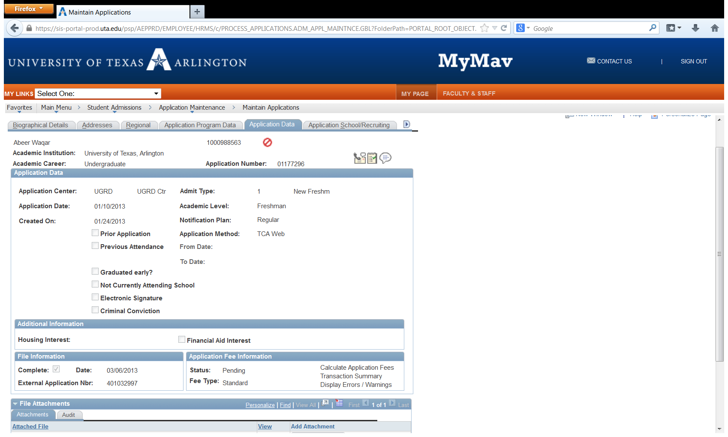

*Figure 6: MyMav>Student Admissions>Application Maintenance>Maintain Applications>Application Data – Freshman Transfer*

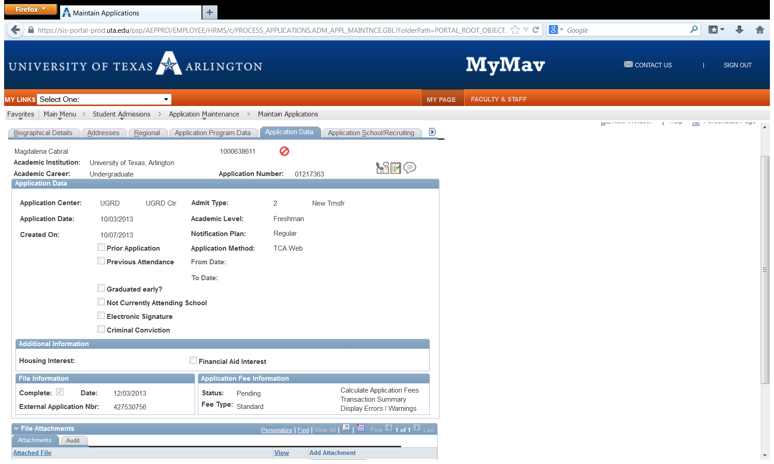

*Figure 7: Grade Forgiveness Request – Student Information – Not Allowed to Submit Messages*

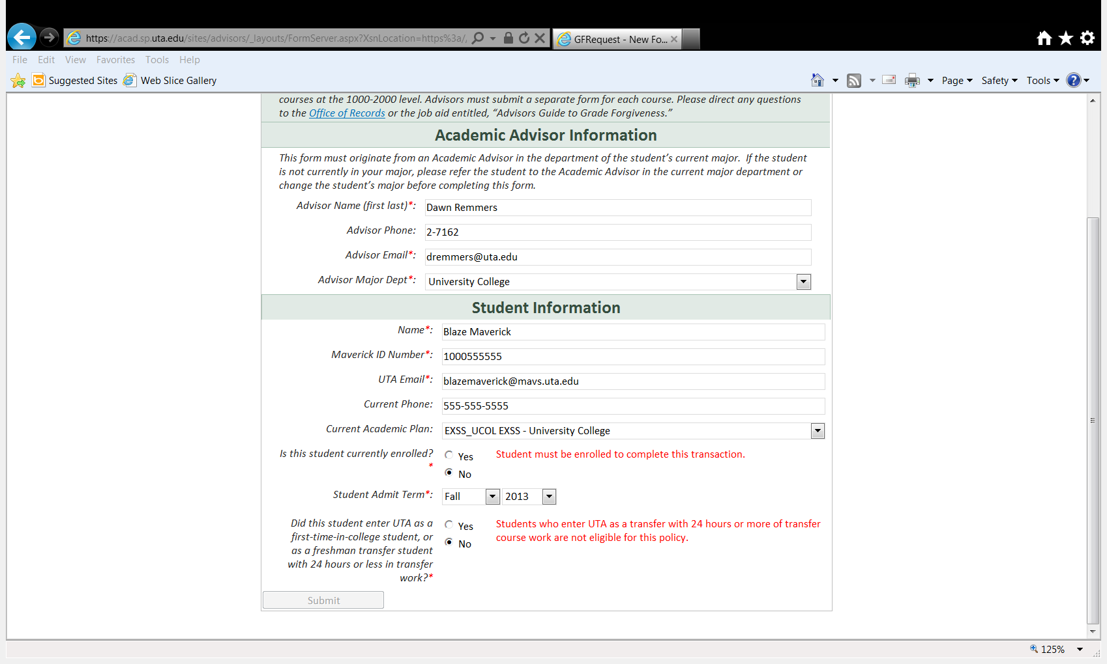

1. Once the advisor has completed the Student Information section, the Request Form will populate with an option to select Grade Omission or Grade Substitution (see Figure 8).
   1. Select Grade Omission or Grade Substitution and then “Submit” for the next section of the form to become available.

### Grade Omission

5-A. Items with a red asterisk must be completed for the form to submit (see Figure 9).

a. Only 1000 and 2000 level courses can be omitted from the overall cumulative GPA calculation. Advisors who enter a 3000 or 4000 level course will not be able to submit the form, and the Course Number Box will highlight with a red-dashed line.

b. Only courses with a letter grade of “D” or “F” can be omitted.

* 1. There are 5 items that an academic advisor should verify in completing the grade omission to ensure compliance with the policy. If an academic advisor cannot verify and check off each of the 5 boxes, the Request should not be submitted. Some of these issues are very important to discuss with the student, as well. For instance, students can only omit a grade for a course if that course is no longer needed for a particular major degree plan. The advisor must verify that the student has changed from the previous major to a new major (e.g. check Unofficial Transcript Academic Plan History for changes) in which that course is no longer needed to complete the degree. The student must also understand that the student cannot return to the previous major (or any major requiring that course) once the omission has been completed…so no gaming the system.

*Figure 8: Grade Forgiveness Request – Omission or Substitution*

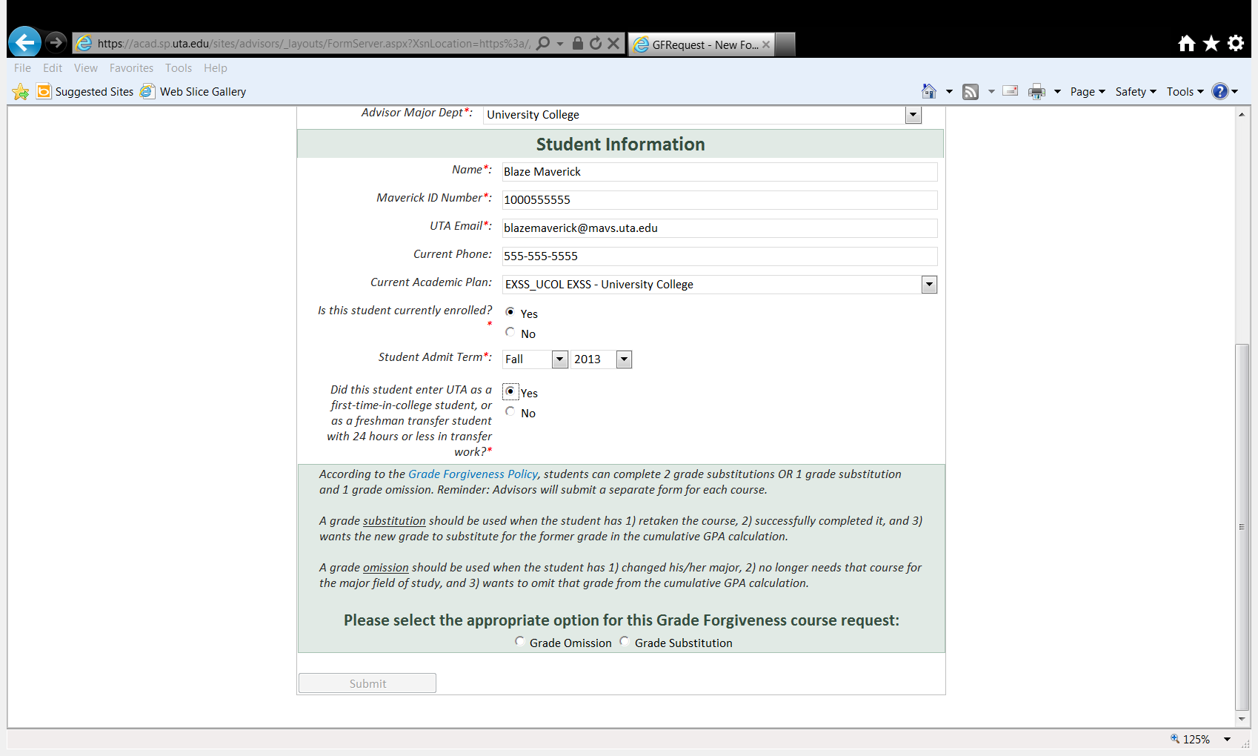

*Figure 9: Grade Forgiveness Request – Grade Omission*

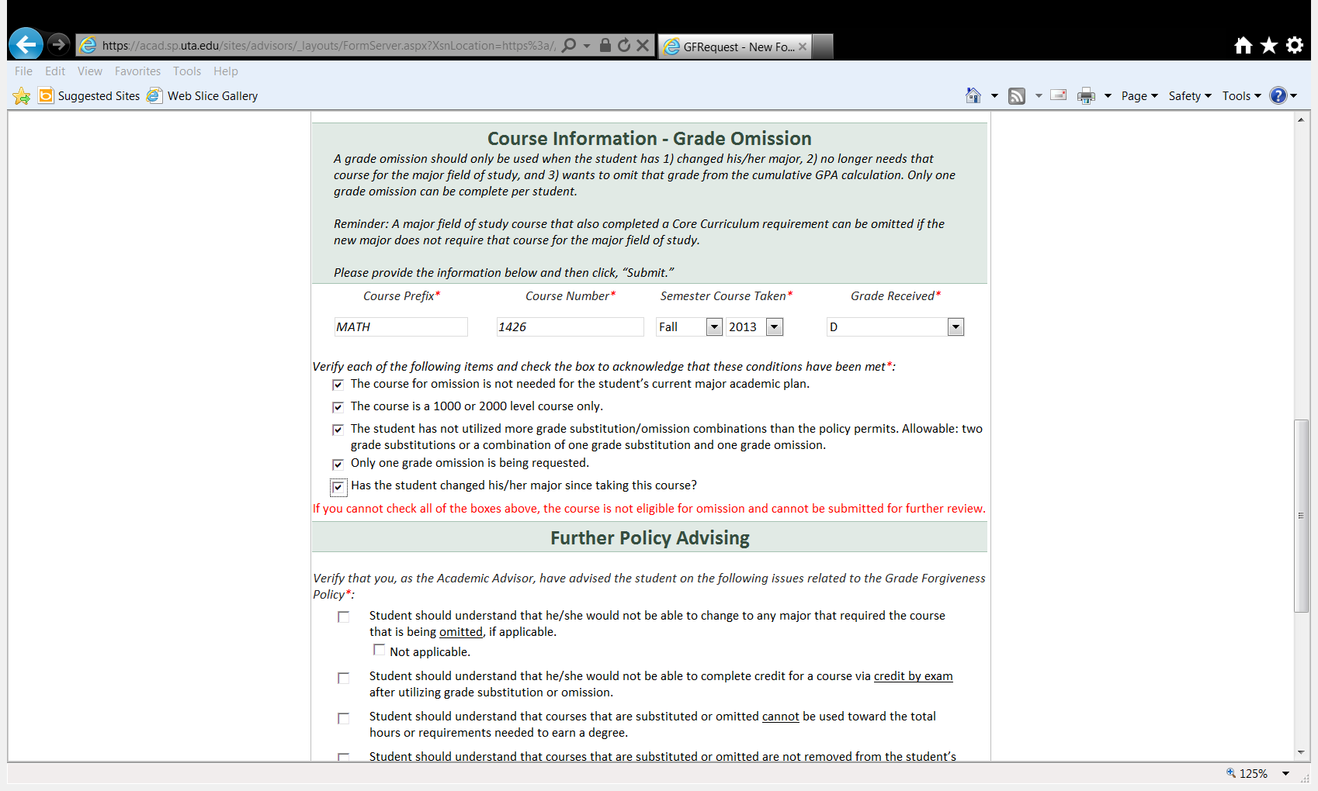

d. Discuss each of the items under Further Policy Advising with the student and **check off the boxes** as the discussion item is completed (see Figure 10). Best practice dictates that students are fully aware of the repercussions of this request and what will and will not happen as a result of an approval of this request. This advising is best done in person, however, if the student is not present when the Request is complete as a result of distance advising, be sure the student has read these issues and acknowledges their understanding in writing before submitting this form to protect the advisor’s actions. Note: The same “Further Policy Advising” options will be at the end of a Grade Substitution Request, as well.

e. Once the form has been fully completed, the Advisor can click “Submit” at the end. Refer to the “General Process” section for next steps.

*Figure 10: Grade Forgiveness Request – Further Policy Advising*

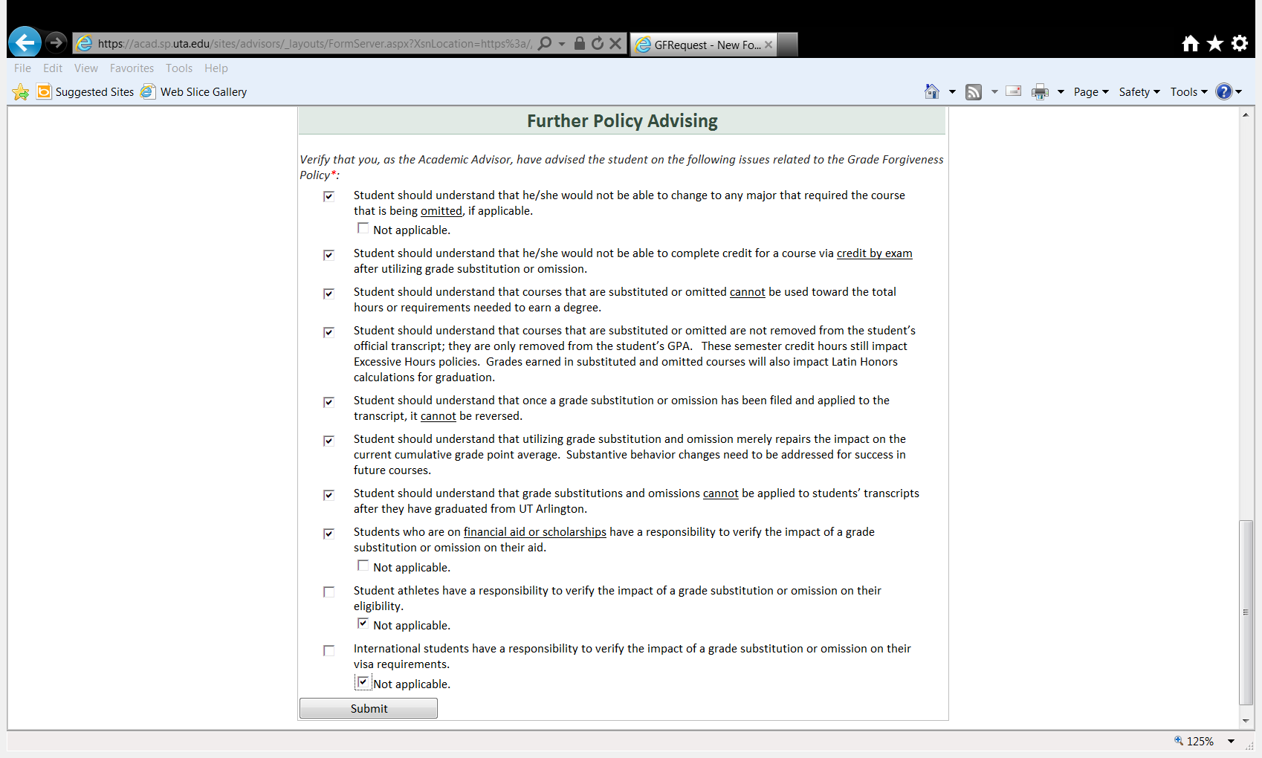

### Grade Substitution

5-B. Items with a red asterisk must be completed for the form to submit (see Figure 11).

1. Only 1000 and 2000 level courses can be substituted. Advisors who enter a 3000 or 4000 level course will not be able to submit the form and the Course Number Box will highlight with a red-dashed line.
2. Only courses with a letter grade of “D” or “F” can be substituted.
3. When a course substitution is completed, the student should have already successfully completed the course and earned a grade of A, B, C, or D. **If the student withdraws from or earns an F in the course, it is not considered a successful completion of the course and should not be submitted for grade substitution. If the student successfully completes the course on the third attempt at the course (i.e., receives a letter grade of A, B, C, or D), a substitution can be requested.**
4. There are 5 items that an academic advisor should verify in completing the grade omission to ensure compliance with the policy. If an academic advisor cannot verify and check off each of the 5 boxes, the Request should not be submitted.
5. Discuss each of the items under Further Policy Advising with the student and **check off the boxes** as the discussion item is completed (see Figure 10). Best practice dictates that students are fully aware of the repercussions of this request and what will and will not happen as a result. This advising is best done in person, however, if the student is not present when the Request is complete as a result of distance advising, be sure the student has read these issues and acknowledges their understanding in writing before submitting this form to protect the advisor’s actions. Note: The same “Further Policy Advising” options will be at the end of a Grade Omission Request as well.

*Figure 11: Grade Forgiveness Request – Grade Substitution*

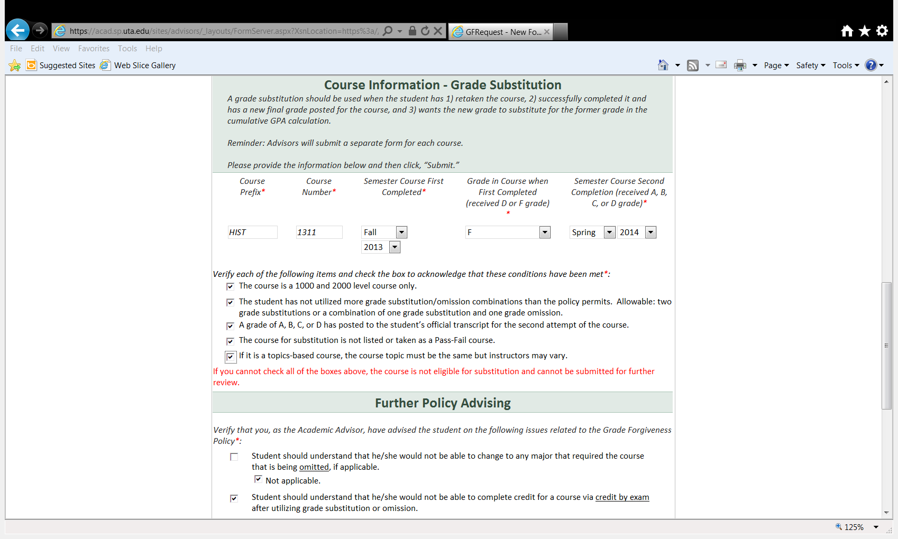

1. Once the form has been fully completed, the Advisor can click “Submit” at the end. Refer to the “General Process” section for next steps.

# For Final Department Approvers

1. Final Approvers will receive an email such as the one depicted in Figure 12.
2. The Final Approver must click on the blue link “Grade Forgiveness Request” in the email to access a request to access the approval process for a particular student.
3. The Final Approver will see the information supplied by the Academic Advisor (see Figure 13). The Final Approver should complete the necessary verification that the student is eligible for the grade forgiveness in accordance with the University policy as well as Department policy and select “Yes” or “No” from the drop down menu. Then supply comments related to the decision, **especially if a “No” (denial) is provided**.
4. Click “Submit.”

*Figure 12: Final Approver Notification Email*

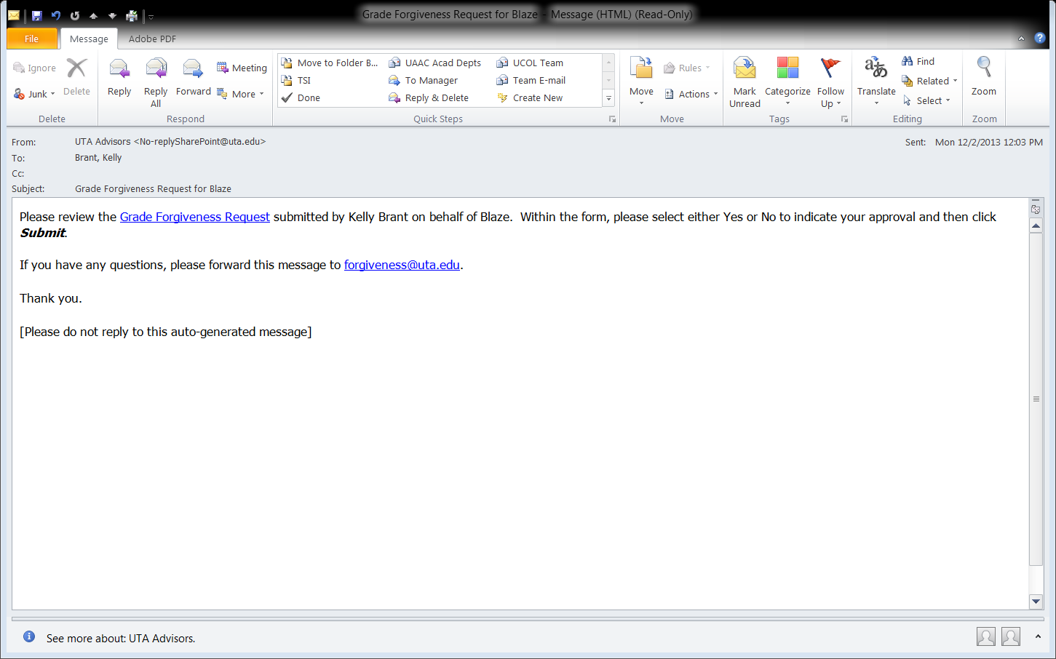

*Figure 13: Final Department Approver View*

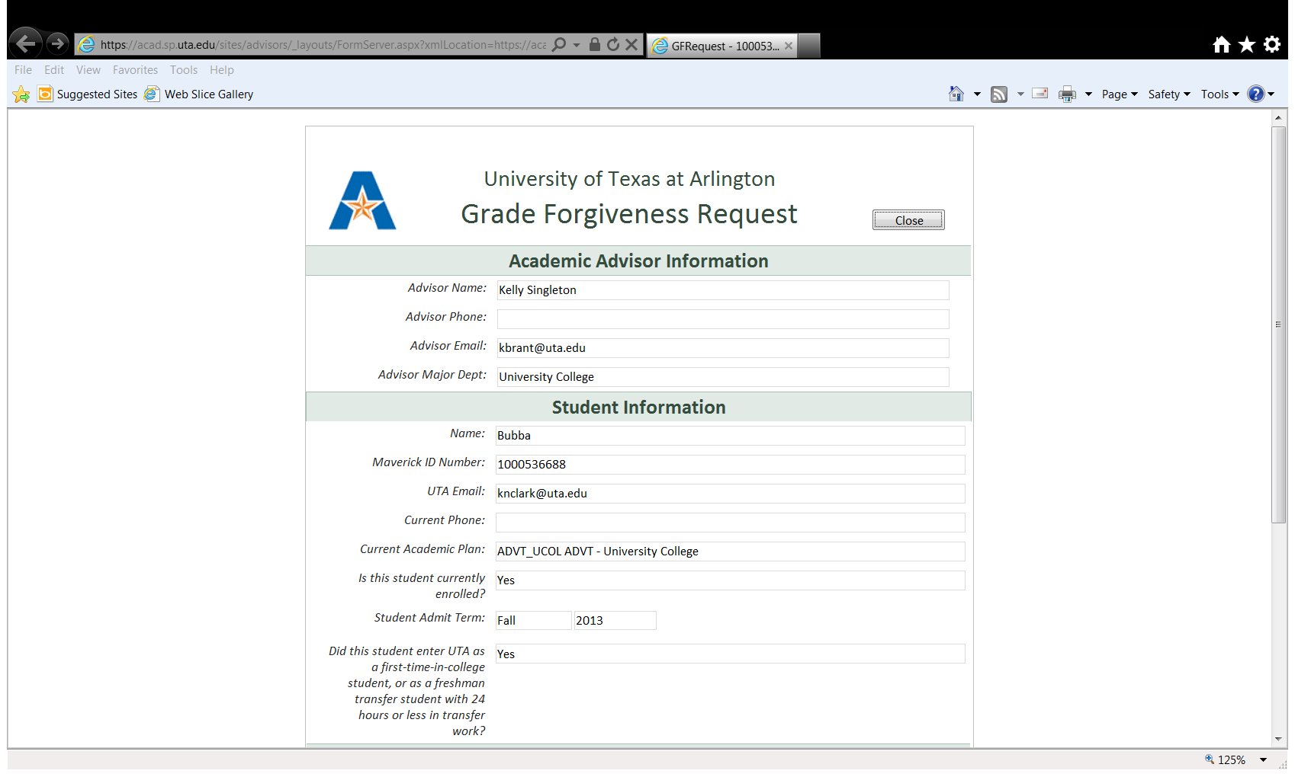

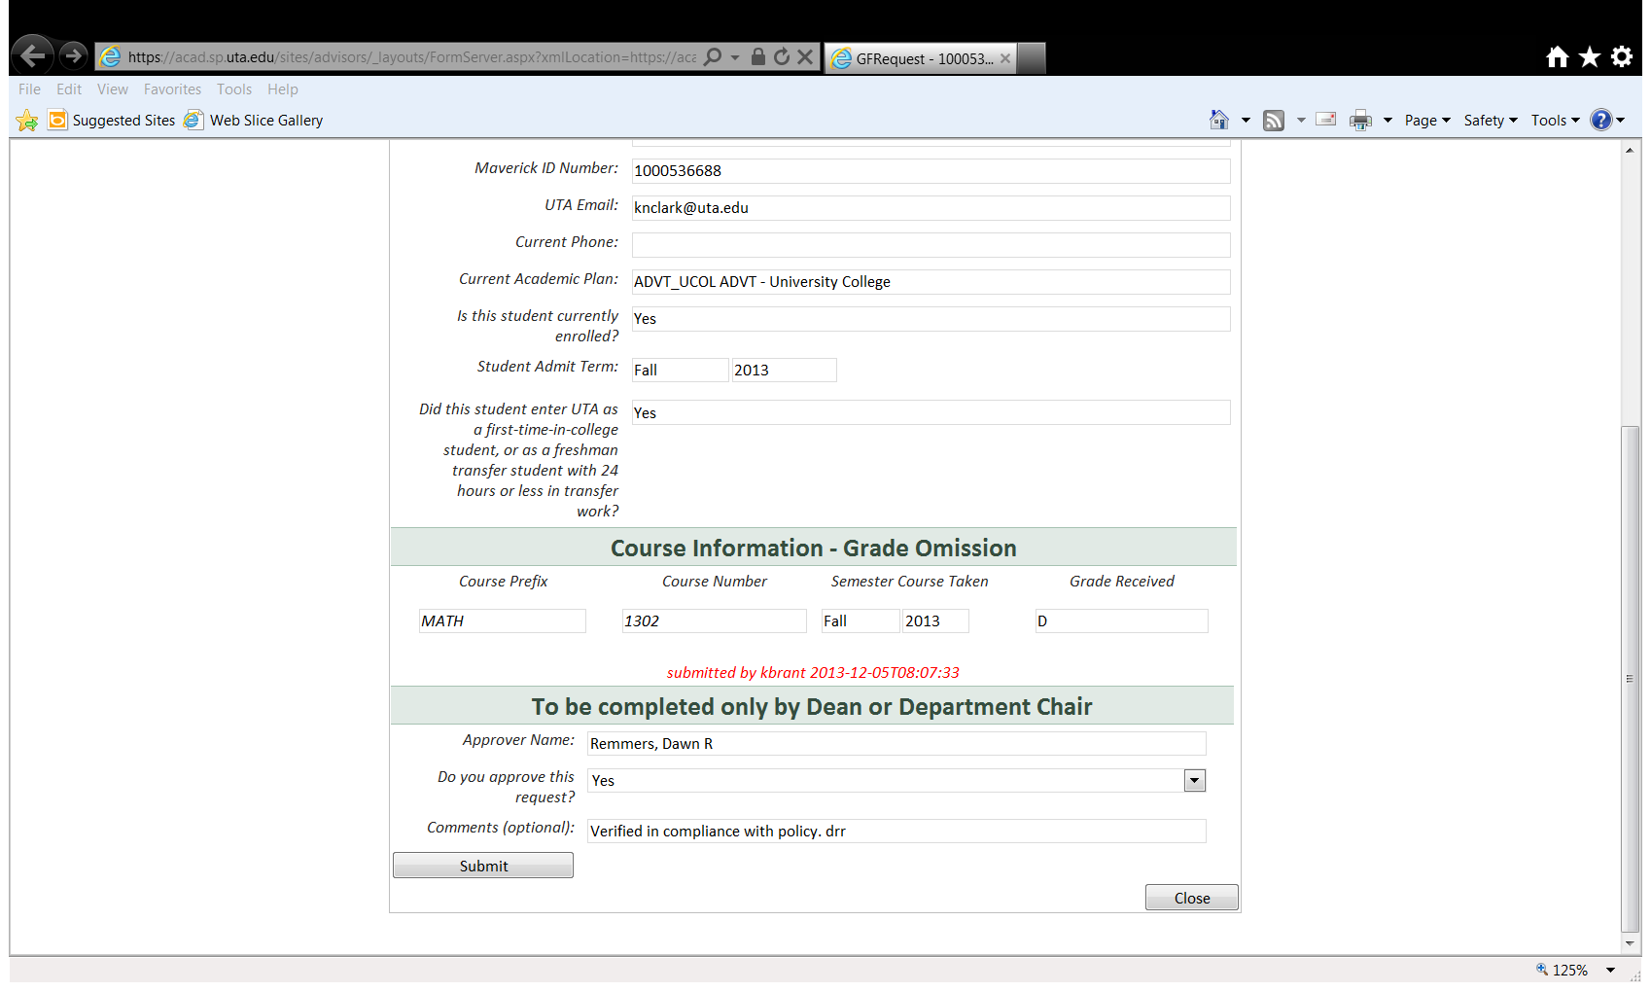

# Student Notifications

1. Students will receive an email (see Figure 14) indicating that an academic advisor has submitted a grade forgiveness request for them.
2. Students will receive an email once the final decision has been approved by the Final Department Approver and ARR has completed their processing.

*Figure 14: Student Notification of Grade Forgiveness Request Filing*

